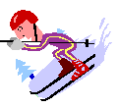

Rearrange these sentences so they make sense:

1. force objects together are is friction which whenever a two is rubbed present.

2. can friction nuisance us both force the of help us to and a be.

3. rough can friction increased surfaces using be by.

4. reduced can using friction lubricants by ball-bearings or be.

5. can friction wear cause produce heat and.

6. oppose can two contact in or friction prevent between surfaces movement.



